Deploying Code to Azure App Service

Objective: To deploy code to Azure App Service
Tools Required: Azure account with administrator access

Prerequisites: None

Steps to be followed:
- Create an App Service plan
- Create App Service
- Deploy and test the web application

Step 1: Create an App Service plan

- Sign in to the Azure portal and click on + Create a resource

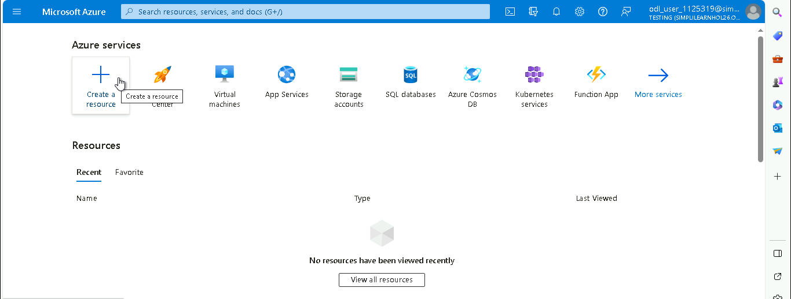

- Search for and select App Service Plan

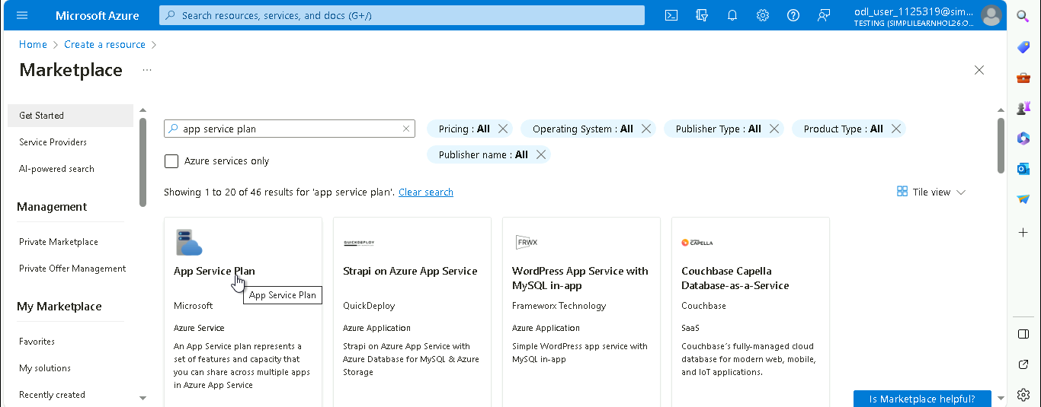

- In the App Service Plan page, click on Create

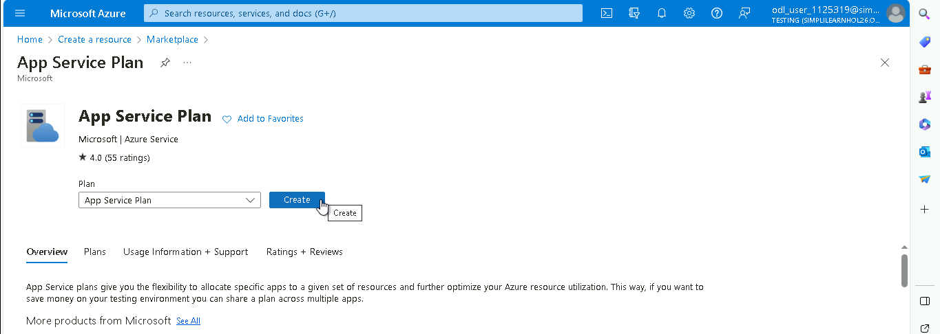

- In the Create App Service plan page, navigate to the Basics tab, and under Project Details, click on Create new to create a new Resource Group

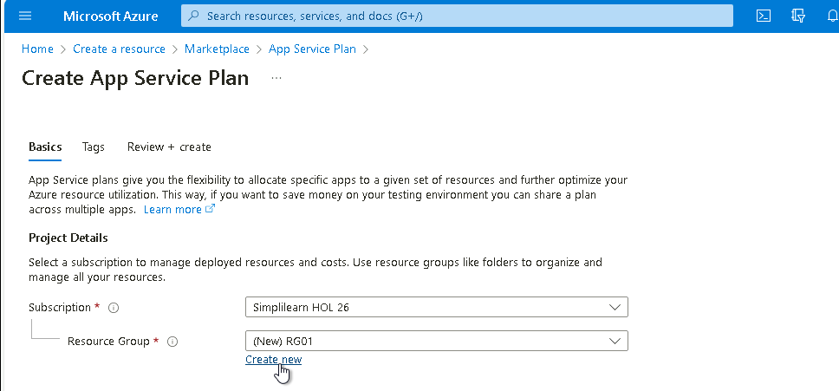

- Under App Service Plan details, provide the details as shown in the below screenshot:

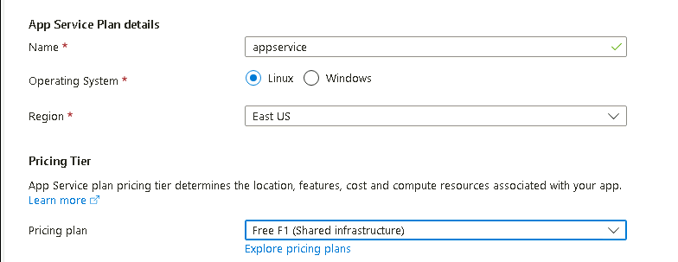

- Click on Review + create

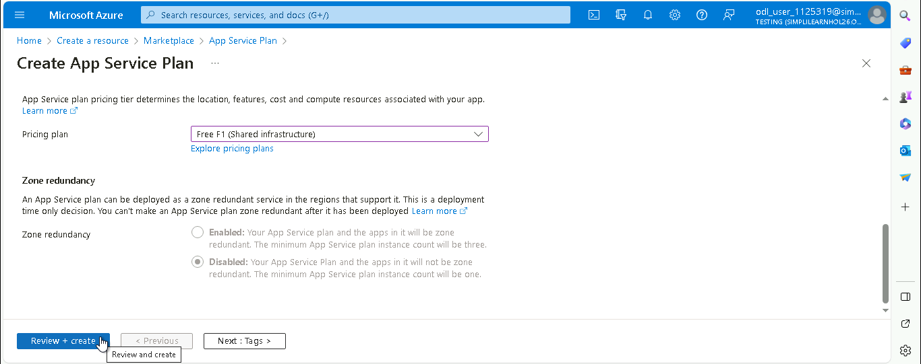

- Click on Create

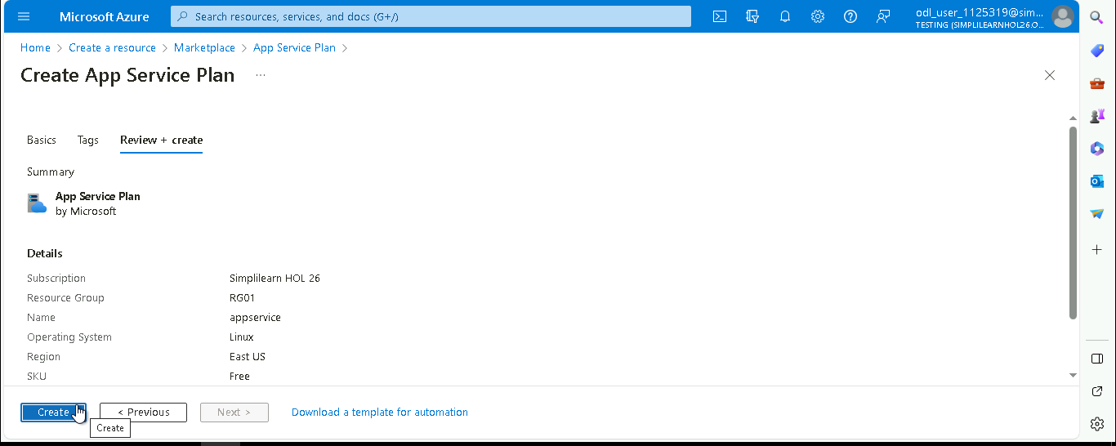

The App Service plan is created successfully.

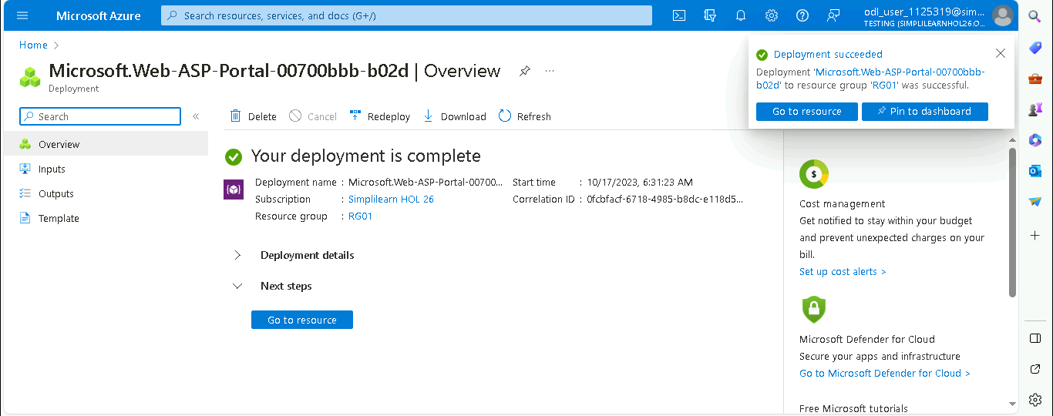

Step 2: Create App Service

  - Click on App Services

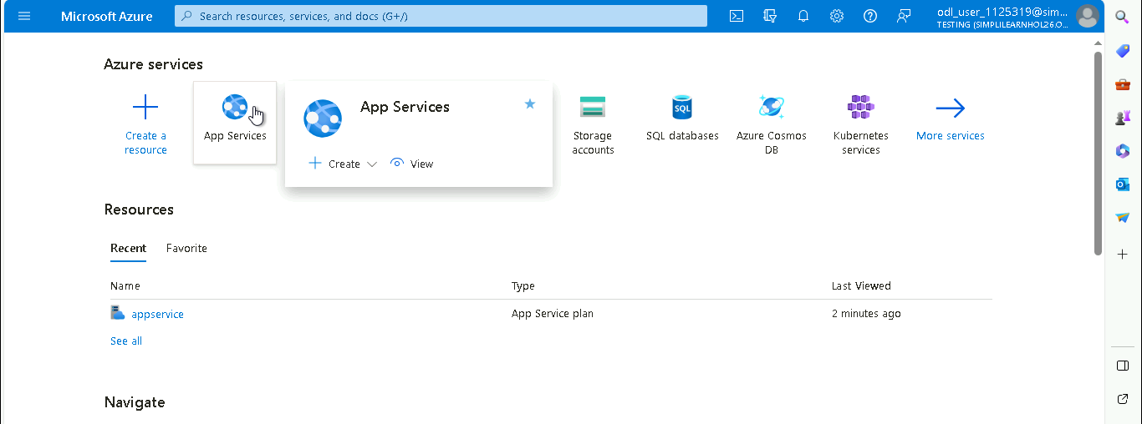

  - In the App Services page, click on + Create drop-down and select + Web App

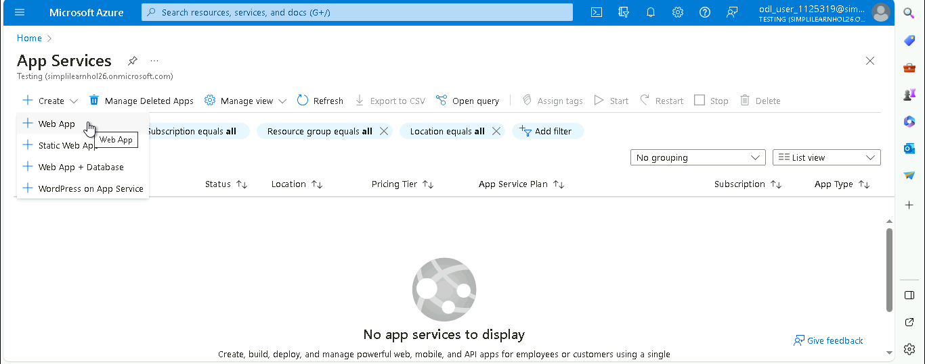

  - In the Create Web App page, under Basics tab, provide the details as shown in the below screenshot and click on Review + create

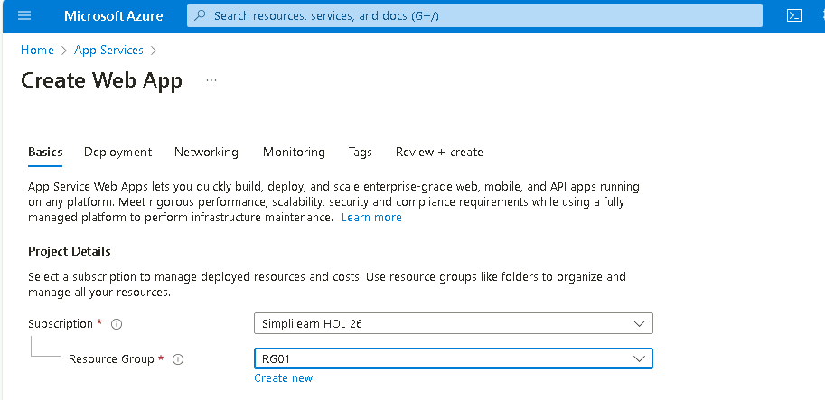

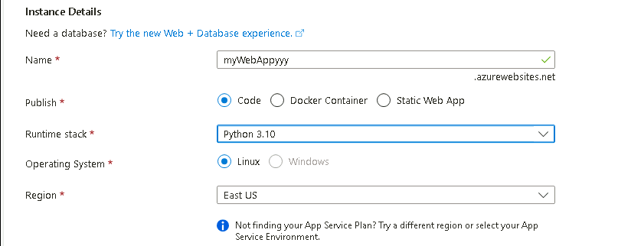

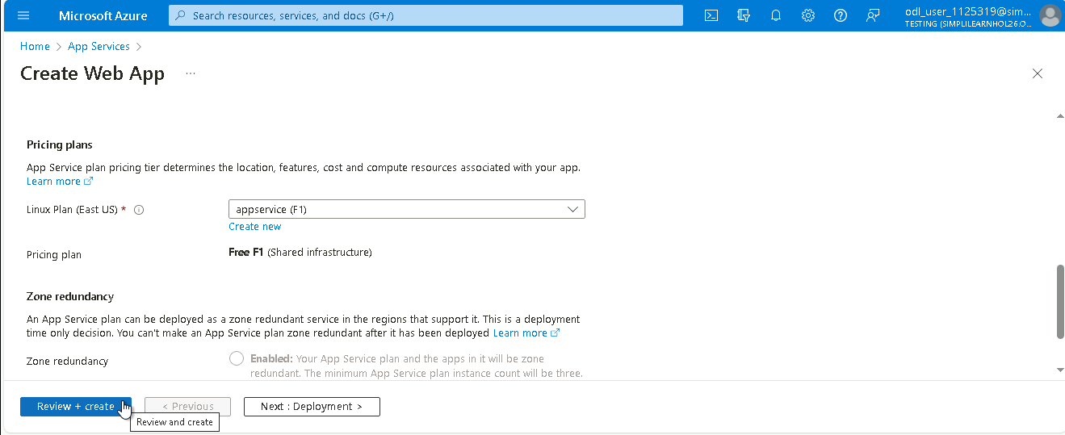

  - Click on Create

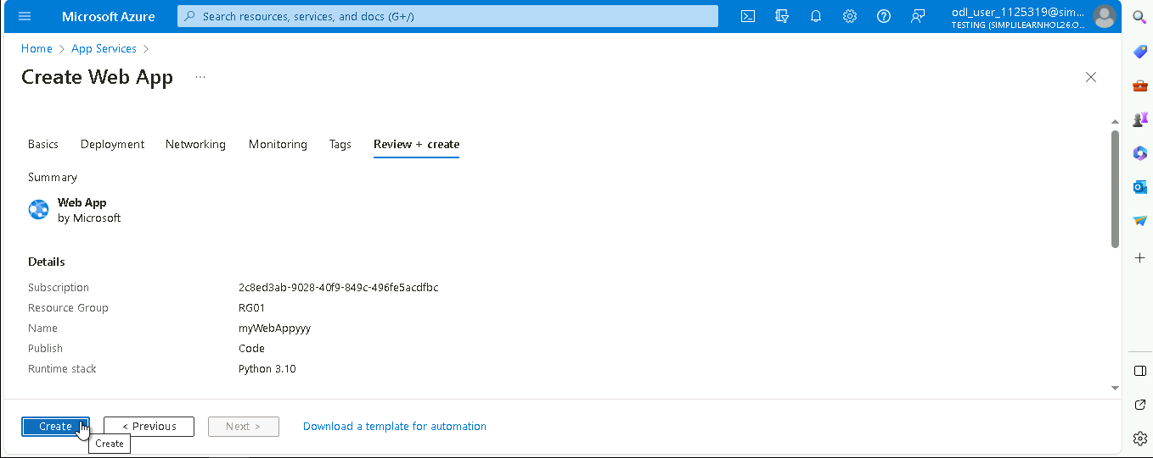

The App Service is created successfully.

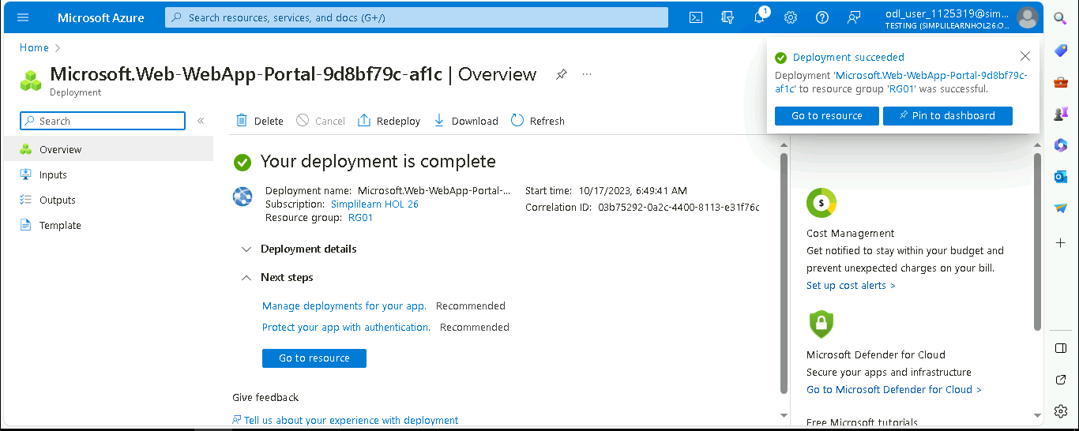

  - Navigate to App Services page and click on the created web app service (myWebAppyyy)

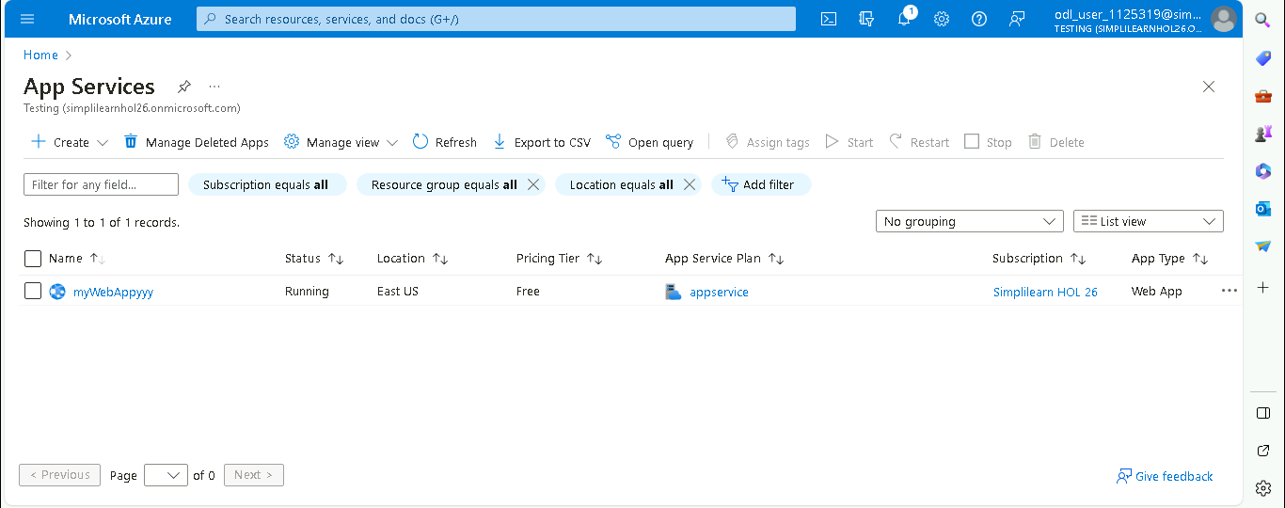

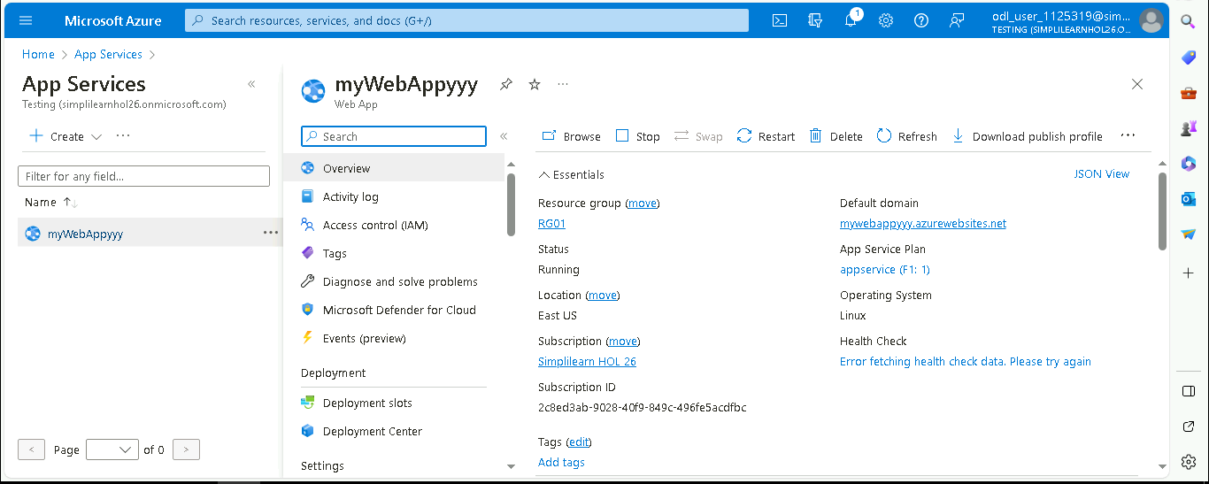

  - In the Overview page, click on Browse to view the App Service website

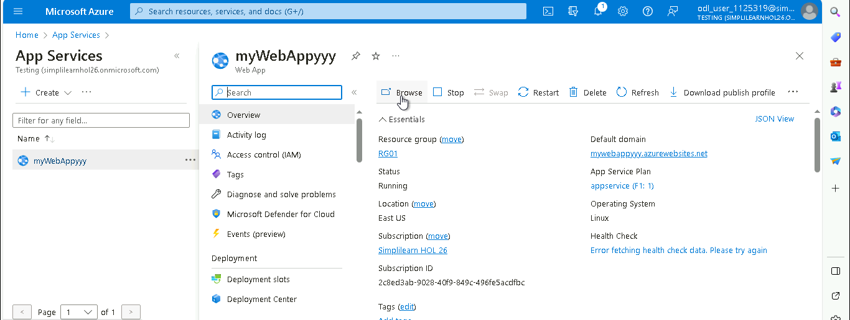

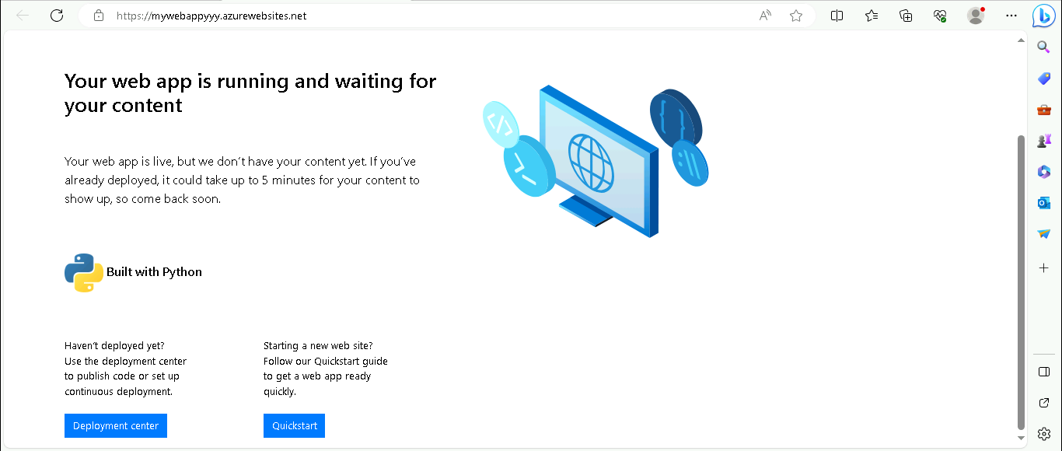

Step 3: Deploy and test the web application

  - Click on Cloud Shell

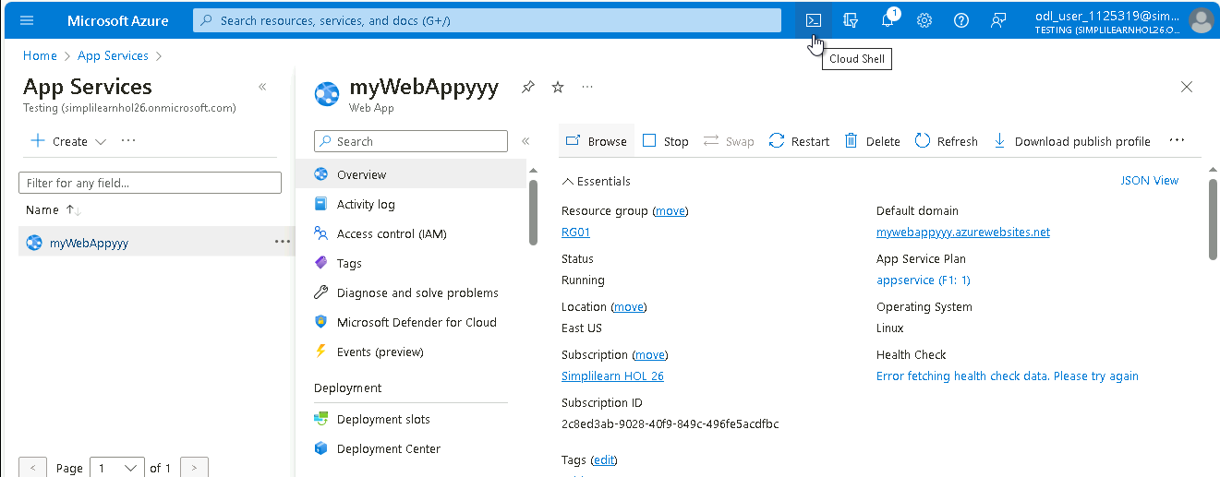

  - Choose Bash

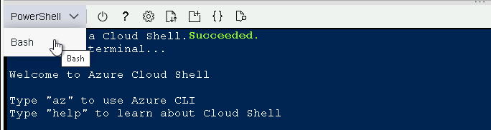

  - Open a new browser and navigate to this link: https://github.com/Azure-Samples/msdocs-python-flask-webapp-quickstart and click on Code

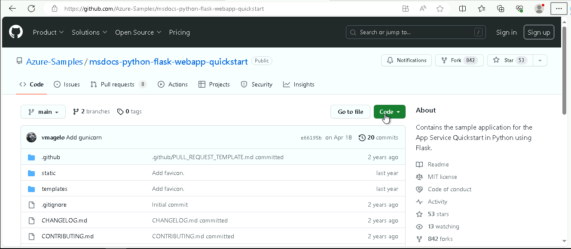

  - Copy the URL of Git repository

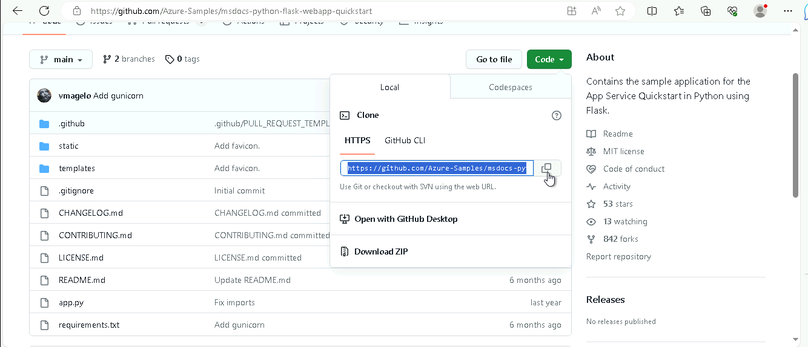

  - In Bash, run the below code:
git clone https://github.com/Azure-Samples/msdocs-python-flask-webapp-quickstart.git

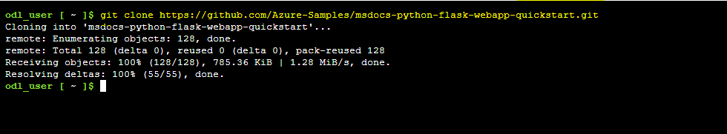

  - Navigate to the directory containing all the files by executing the following command:
cd msdocs-python-flask-webapp-quickstart

  - To link the Git repository to your Azure web (myWebAppyyy), execute the following command:
az webapp up -n myWebAppyyy

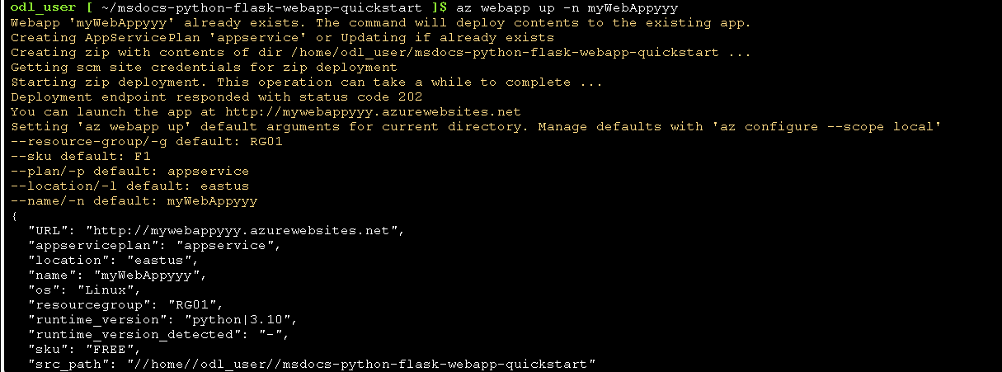

  - Navigate to the created App Service and click on Browse

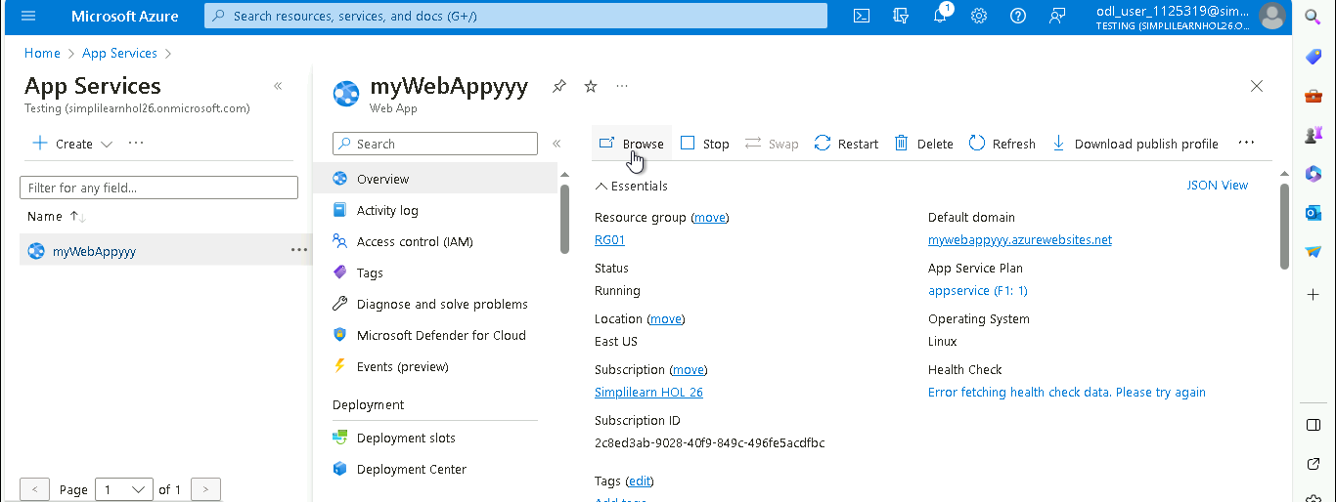

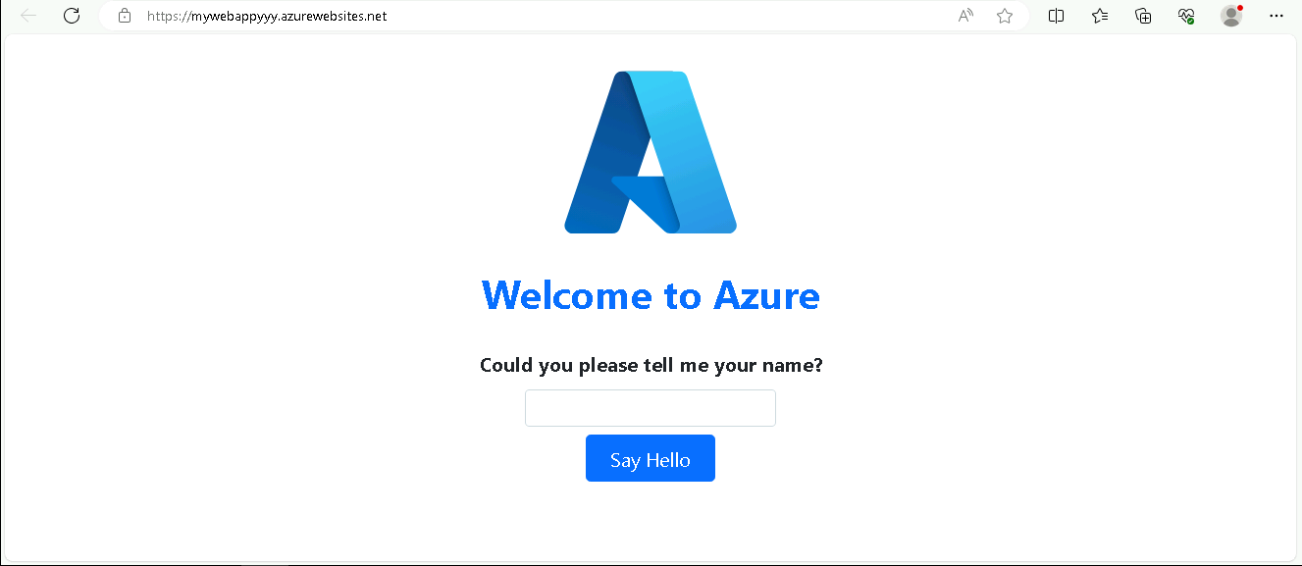

  - Provide a name and click on Say Hello

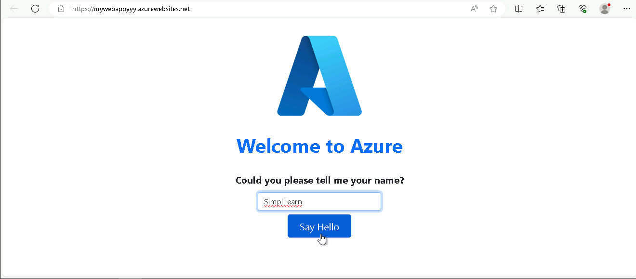

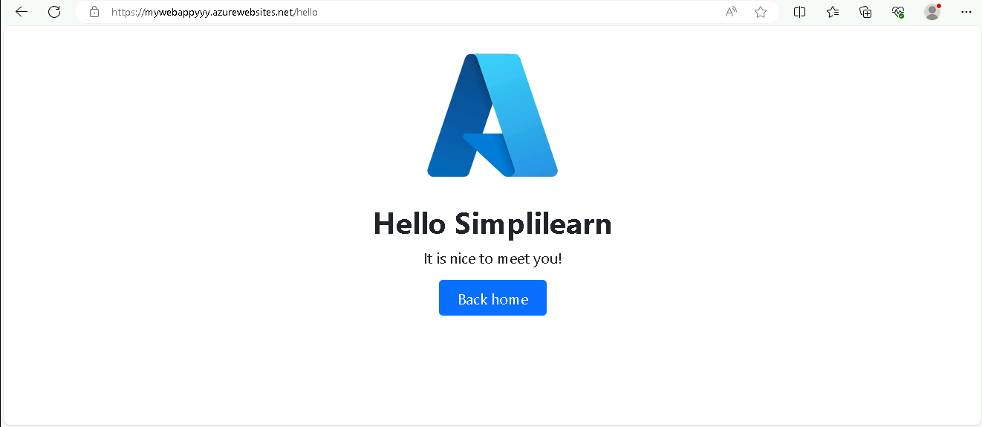

The web application is running successfully.

With this, you have successfully deployed the code to the Azure App Service.

